# The Benefits of Sustainable Living

## Introduction to Sustainable Living

Sustainable living involves making choices that reduce our impact on the environment, conserve resources, and promote the well-being of future generations. It encompasses various practices and lifestyle changes that contribute to environmental conservation and improved quality of life. This document explores the benefits of sustainable living, including its impact on the environment, health, and economy.

## **1. Environmental Benefits**

Sustainable living practices play a crucial role in protecting and preserving the environment. By reducing our ecological footprint, we help mitigate climate change and conserve natural resources.

### **1.1 Reducing Carbon Footprint**

* **Energy Efficiency:** Using energy-efficient appliances and insulating homes reduces energy consumption and greenhouse gas emissions.
* **Renewable Energy:** Switching to renewable energy sources like solar or wind power helps decrease reliance on fossil fuels.

### **1.2 Conserving Natural Resources**

* **Water Conservation:** Implementing water-saving practices such as fixing leaks and using low-flow fixtures conserves water.
* **Waste Reduction:** Reducing, reusing, and recycling helps minimize waste and reducesthe strain on landfills.

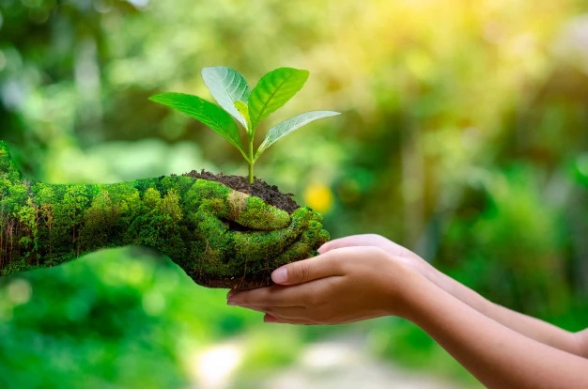

2. Health Benefits

Adopting sustainable living practices can significantly enhance personal and community health. These practices often lead to cleaner air, healthier food choices, and improved overall well-being.

2.1 Improved Air Quality

Reducing Pollution: Using public transportation or electric vehicles reduces air pollution and improves respiratory health.

Green Spaces: Creating and maintaining green spaces in urban areas helps purify the air and provides areas for physical activity.

2.2 Healthier Food Choices

Organic Farming: Choosing organic produce reduces exposure to harmful pesticides and supports healthier soil.

Local Foods: Consuming locally-sourced foods decreases the carbon footprint associated with transportation and supports local farmers.

## **3. Economic Benefits**

Sustainable living not only benefits the environment and health but also offers economic advantages. Implementing sustainable practices can lead to cost savings and economic growth.

### **3.2 Economic Growth**

* **Job Creation:** The growth of the green economy creates job opportunities in areas such as renewable energy, recycling, and sustainable agriculture.
* **Innovation and Efficiency:** Embracing sustainability drives innovation and increases efficiency in various industries.

## **4. How to Start Living Sustainably**

Adopting a sustainable lifestyle involves making gradual changes that align with environmental and personal values. Here are practical steps to get started.

### **4.1 Small Changes at Home**

* **Energy-efficient Lighting:** Replace incandescent bulbs with LED lights.
* **Reduce Single-use Plastics:** Use reusable bags, bottles, and containers.

### **4.2 Community Involvement**

* **Support Local Initiatives:** Participate in community clean-up events and support local sustainability programs.
* **Educate Others:** Share information about sustainable practices and encourage others to make eco-friendly choices.

Economic benefits of sustainable living

**Conclusion**

Sustainable living offers numerous benefits that extend to environmental protection, personal health, and economic prosperity. By making conscious choices and adopting sustainable practices, individuals and communities can contribute to a healthier planet and a brighter future for generations to come.